Ottawa Community Food Resource

The catchment areas included:

West to Kanata/Stittsville, East to Orleans, South to Barrhaven/Manotick
Community Garden

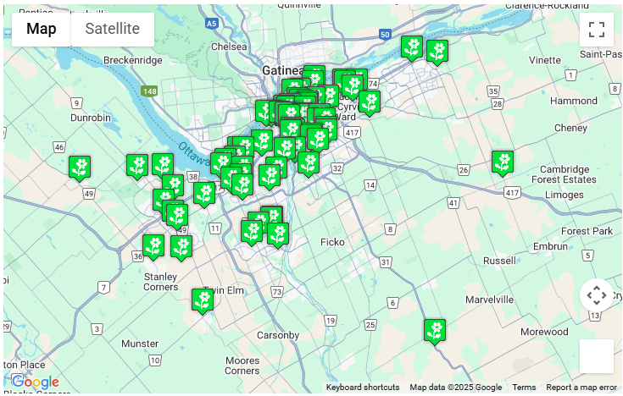

Phone: 613-824-7771 (voicemail only)
Contact: Kath Stevenson, Community Gardening Network Coordinator
Email: communitygardening@justfood.ca

Website: To find out about the nearest food bank in your area visit justfood.ca/community-gardening-network/ and click “Find a Community Garden”

